**Finance and Economics Introduction concepts:**

a) **Define Economics**: Economics is the social science that studies the production, distribution, and consumption of goods and services. It examines how individuals, businesses, governments, and nations make choices about how to allocate scarce resources to satisfy their unlimited wants and needs.

b) **State the Basic Problem of Economics**: The basic problem of economics is the issue of scarcity. Since resources (like time, labor, and raw materials) are limited, but human wants and needs are unlimited, individuals, businesses, and governments must make choices about how to allocate these resources most efficiently. This gives rise to the fundamental questions of what to produce, how to produce, and for whom to produce.

c) **Explain the Scope and Methodology of Economics**:

* **Scope**: Economics covers a wide range of areas, including:
  + Microeconomics: Study of individual consumers and producers.
  + Macroeconomics: Study of the economy as a whole, including issues like inflation, unemployment, and economic growth.
  + Development Economics: Focuses on improving the economic conditions of developing countries.
  + International Economics: Study of how countries interact economically.
  + Environmental Economics: Study of how economic activity affects the environment and how environmental policies affect the economy.
  + Behavioral Economics: Examines how psychological factors influence economic decisions.
* **Methodology**: Economists use a variety of methods to study economic issues, including:
  + Theoretical Models: Simplified representations of the real world used to understand and predict economic behavior.
  + Empirical Analysis: Using data to test economic theories and models.
  + Experiments: Controlled studies to understand economic behavior.
  + Case Studies: In-depth examinations of specific economic situations or policies.

d) **Compare and Contrast the Two Branches of Economics**:

| **Criteria** | **Microeconomics** | **Macroeconomics** |
| --- | --- | --- |
| **Focus** | Individual units such as a household or a firm | The economy as a whole |
| **Key Questions** | How do consumers make choices? How do firms maximize profit? | What causes inflation? How can unemployment be reduced? |
| **Examples** | Pricing of a specific product, consumer behavior for a particular good | National income, general price level, national employment |
| **Applications** | Business strategies, market research | Monetary and fiscal policy, international trade policy |

e) **Compare and Contrast Various Economic Systems**:

| **Economic System** | **Definition** | **Advantages** | **Disadvantages** |
| --- | --- | --- | --- |
| **Capitalism** | An economic system where private entities own and operate the means of production. | Efficient allocation of resources, innovation, consumer choice | Income inequality, can lead to monopolies |
| **Socialism** | Means of production are owned and controlled by the state or the public. | Reduced income inequality, provision of public goods | Less efficient, less incentive for innovation |
| **Communism** | A classless society where all means of production are communally owned. | No class distinctions, basic needs are met for all | Lack of economic freedom, inefficiencies |
| **Mixed Economy** | Combines elements of both capitalism and socialism. | Balances benefits of both systems, public and private enterprise | Potential for excessive regulation, can have inefficiencies |

**Topic 2: Elements of Microeconomics**

**Law of Supply and Demand**: The law of supply and demand is a fundamental principle in economics that describes the relationship between the price of a good and the quantity supplied and demanded.

* **Law of Demand**: As the price of a good rises, the quantity demanded falls, and vice versa, ceteris paribus (all other things being equal). This negative relationship is due to factors like the substitution effect and the income effect.
* **Law of Supply**: As the price of a good rises, the quantity supplied rises, and vice versa, ceteris paribus. This positive relationship is because higher prices provide an incentive for producers to produce more.
* **Demand**:
  + **Law of Demand**: This law states that, all else being equal, as the price of a product increases, the quantity demanded decreases, and vice versa. In other words, there's an inverse relationship between price and quantity demanded.
  + **Individual Demand and Markets**: Individual demand refers to the quantity of a good or service that a single consumer is willing to purchase at a given price. Market demand is the sum of all individual demands for a particular good or service.
  + **Determinants of Demand**: Factors that can shift the demand curve include:
    - Income of consumers
    - Prices of related goods (substitutes and complements)
    - Tastes and preferences
    - Expectations about future prices
    - Number of buyers in the market
* **Supply**:
  + **Determinants of Supply**: Factors that can shift the supply curve include:
    - Production costs
    - Technological advancements
    - Prices of related goods in production
    - Expectations about future prices
    - Number of sellers in the market
* **The Concept of Equilibrium**:
  + **Equilibrium Price**: The equilibrium price, also known as the market-clearing price, is the price at which the quantity demanded equals the quantity supplied. At this price, there's no surplus or shortage in the market.
  + **Changes in the Economic Environment**: Any external factor that affects demand or supply can lead to a new equilibrium. For instance, a technological advancement (reducing production costs) can increase supply, leading to a lower equilibrium price and higher quantity. Conversely, a surge in consumer income can increase demand, leading to a higher equilibrium price and quantity.
* **Application of Price Theory**: Price theory studies how the allocation of resources and distribution of goods and services are determined through the price mechanism in markets.

**a) Define the Concept of a Market**: A market is a setting in which buyers and sellers interact to exchange goods, services, or resources. Markets can be physical places, like a farmers' market, or virtual, like an online marketplace. They can be local, national, or global in scope.

**b) Determine the Equilibrium Price and Quantity for Goods and Services**: The equilibrium price and quantity are determined where the supply and demand curves intersect. At this point:

* The quantity that producers are willing to produce and sell equals the quantity that consumers are willing to buy.
* There's no surplus or shortage of goods.

**c) Explain How Changes in the Economic Environment Influence the Demand, Supply, and Equilibrium**:

* **Demand**: Changes in the economic environment, such as a rise in consumer income, can increase demand for normal goods. Conversely, an economic downturn might decrease demand as consumers cut back on spending.
* **Supply**: Economic factors like technological advancements can reduce production costs, leading to an increase in supply. On the other hand, natural disasters or geopolitical tensions can disrupt supply chains, reducing supply.
* **Equilibrium**: Any change in demand or supply will result in a new equilibrium price and quantity. For instance:
  + If demand increases (with supply constant), the equilibrium price and quantity will rise.
  + If supply decreases (with demand constant), the equilibrium price will rise, but the quantity will decrease.

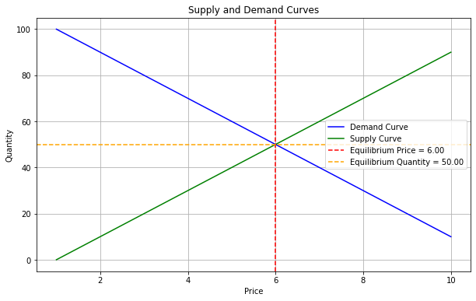

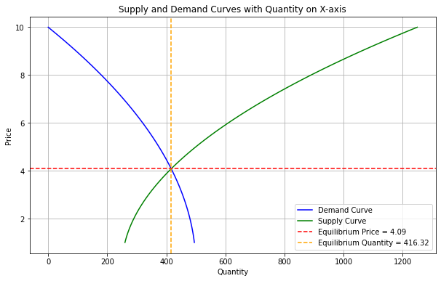

In essence, the economic environment plays a crucial role in shaping the dynamics of demand, supply, and market equilibrium. External factors can shift demand and supply curves, leading to changes in prices and quantities in the market.

**Theory of Production**: The theory of production examines how businesses decide how much of each commodity to produce and how much of each input to use in producing it. It focuses on the processes by which inputs (like labor, capital, and raw materials) are transformed into outputs.

**Consumer Behavior**: Consumer behavior studies how individuals, groups, and organizations select, buy, use, and dispose of goods, services, ideas, or experiences to satisfy their needs and desires.

**a) Explain the Three Stages of Production**:

1. **Increasing Returns to Scale (Stage I)**: In this stage, as more units of a variable input (like labor) are added, the total output increases at an increasing rate. This is often due to underutilization of fixed resources at the start.
2. **Diminishing Returns to Scale (Stage II)**: As even more units of the variable input are added, the total output continues to increase but at a decreasing rate. This is the stage where the law of diminishing returns starts to take effect.
3. **Negative Returns to Scale (Stage III)**: After a certain point, adding more units of the variable input will cause the total output to decrease. This happens when the variable input becomes too much relative to the fixed inputs, leading to inefficiencies.

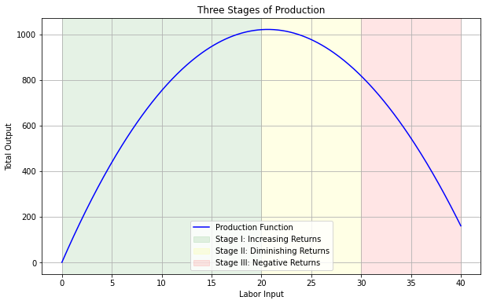

**b) State the Law of Diminishing Returns**: The law of diminishing returns states that, in a production process, as one input variable is increased, there will be a point at which the marginal per-unit output will start to decrease, holding all other factors constant. In other words, after some point, each additional unit of the variable input yields less and less additional output.

**c) Apply the Theory of Production in Making Managerial Decisions**: The theory of production can guide managerial decisions in various ways:

* **Optimal Resource Allocation**: Managers can determine the optimal mix of inputs to maximize output or minimize costs.
* **Scaling Production**: By understanding the stages of production, managers can decide when to scale up or down production.
* **Technological Investments**: Understanding the production function can guide decisions about investing in technology or other capital to increase productivity.
* **Pricing Decisions**: Knowing the cost structure and how it changes with production levels can inform pricing strategies.

**d) Define Utility and Find Consumer Equilibrium**:

* **Utility**: Utility is a measure of the satisfaction or happiness that a consumer derives from consuming a good or service. It's a subjective measure and can vary from person to person.
* **Consumer Equilibrium**: A consumer reaches equilibrium when they allocate their income in such a way that the last unit of money spent on each good or service yields the same increase in utility. Mathematically, a consumer is in equilibrium when the marginal utility per dollar spent is the same for all goods and services. In other words:

$$\frac{{MU}_{1}}{P_{1}}= \frac{{MU}_{2}}{P_{2}}=…=\frac{{MU}_{n}}{P_{n}}$$

Where ${MU}_{i}$ ​ is the marginal utility of good $i$ and $P_{i}​$ is the price of good $i$.

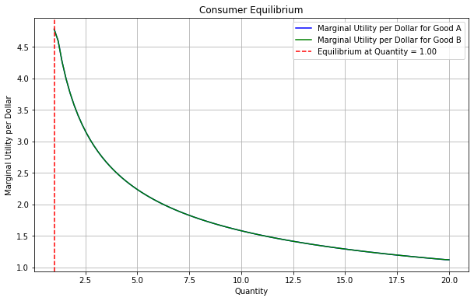

In this visualization:

* The blue curve represents the marginal utility per dollar for Good A.
* The green curve represents the marginal utility per dollar for Good B.
* The red dashed line indicates the quantity at which the consumer reaches equilibrium, i.e., the point where the marginal utility per dollar is the same for both goods.

This equilibrium condition ensures that the consumer is getting the maximum possible utility from their expenditure, given their budget constraint.

**Utility**

**Definition**: Utility is a measure used in economics to represent the satisfaction or happiness derived from consuming a good or service. It's a subjective concept, meaning it can vary from person to person. Utility helps explain the choices consumers make by assuming that individuals will choose the combination of goods and services that maximizes their satisfaction.

**Types of Utility**:

1. **Total Utility (TU)**: It represents the total satisfaction obtained from consuming a certain quantity of a good or service.
   * **Formula**: $TU=U_{1}​+U_{2}​+⋯+U_{n}​$

Where $U_{1}​,U_{2}​,…,U_{n}​ are the utilities derived from the 1st, 2nd, ... n-th unit of the good$.

1. **Marginal Utility (MU)**: It is the additional satisfaction derived from consuming one more unit of a good or service.
   * **Formula**: $MU={TU}_{new}​-{TU}_{previous}​$ or ${MU}_{n}​={TU}_{n}​-{TU}_{n-1}​$

Where

${MU}_{n}​ is the marginal utility of the n^{th} unit,$

${TU}_{n}​ is the total utility after consuming n units, and$

${TU}_{n-1}​ is the total utility after consuming n-1 units.$

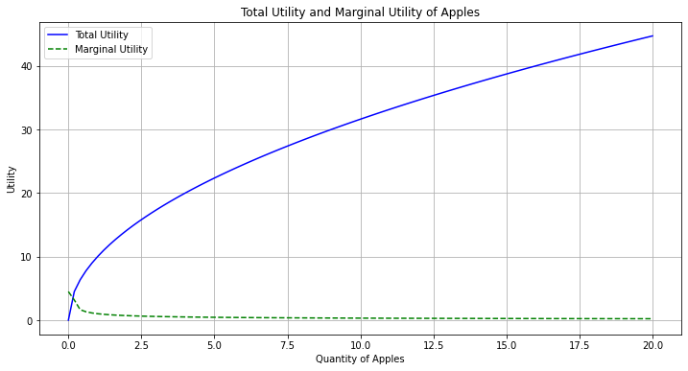

* The plot shows the total utility and marginal utility curves for apples. As you can see, as the quantity of apples increases, the total utility increases at a decreasing rate, and the marginal utility decreases.

**Law of Diminishing Marginal Utility**:

This law states that as a person consumes more and more units of a good, the additional satisfaction (marginal utility) derived from consuming each additional unit of the good decreases, keeping other things constant. In formula terms, this means:

$${MU}_{n+1}​<{MU}_{n}​ for increasing values of n.$$

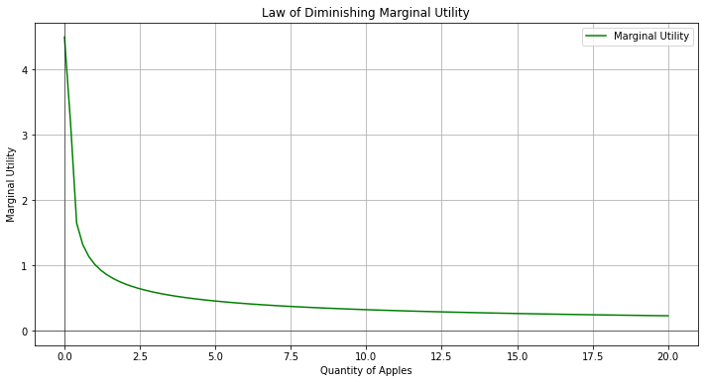

The plot visualizes the law of diminishing marginal utility. As the quantity of apples consumed increases, the marginal utility (additional satisfaction) derived from each additional apple decreases.

**Utility Maximization**: Consumers aim to maximize their utility given their budget constraints. The condition for utility maximization is:

$$​\frac{{MU}_{A}}{P_{A}}​​=​\frac{{MU}_{B}}{P_{B}}$$

​​ Where:

* ${MU}_{A}$ and ${MU}_{B}$ are the marginal utilities of goods A and B, respectively.
* $P_{A}$ and $P_{B}$ ​ are the prices of goods A and B, respectively.

This equation states that the last dollar spent on any good should yield the same increase in utility. If this condition is not met, the consumer can increase their total utility by reallocating their expenditure.

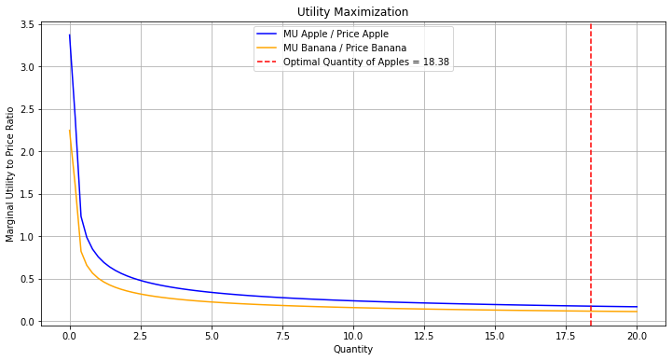

The plot demonstrates utility maximization. The consumer will allocate their budget between apples and bananas in such a way that the marginal utility per dollar spent is the same for both goods. The red dashed line indicates the optimal quantity of apples the consumer should buy to maximize utility given the prices and budget constraint.

**Indifference Curves**: In the context of utility, indifference curves represent combinations of goods that give the consumer the same level of satisfaction. The slope of an indifference curve, known as the marginal rate of substitution (MRS), represents the rate at which a consumer is willing to trade one good for another while maintaining the same level of utility.

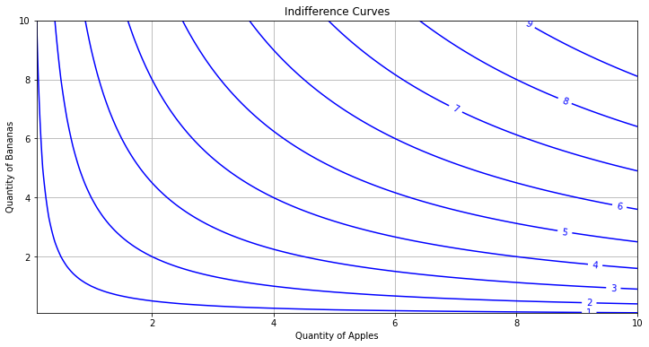

* The plot shows indifference curves for combinations of apples and bananas. Each curve represents a different level of utility. The consumer is indifferent between any two points on the same curve since they provide the same level of utility.

**Note**: Utility is a subjective measure and cannot be directly observed. It's often used in a theoretical context to explain consumer behavior. In practice, economists use observable choices to infer about underlying preferences and utility.

**a) Define National Income and Its Related Concepts**:

* **National Income (NI)**: National income is the total value of all goods and services produced in a country over a specific time period, typically a year. It represents the aggregate wealth created by a nation.

Related Concepts:

* + **Gross Domestic Product (GDP)**: The total value of all goods and services produced within a country's borders in a specific time frame.
  + **Net Domestic Product (NDP)**: GDP minus depreciation on a country's capital goods.
  + **Gross National Product (GNP)**: GDP plus net income from abroad (like earnings from foreign investments).
  + **Net National Product (NNP)**: GNP minus depreciation.
  + **Personal Income**: Total income received by individuals, including wages, rents, interest, and dividends.
  + **Disposable Income**: Personal income minus personal taxes, representing the income available for consumption and savings.

**Gross Domestic Product (GDP):**

**Definition:** GDP represents the total monetary value of all goods and services produced within the borders of a country over a specific period, typically a year.

**Formula: $GDP = C + I + G + (X - M)$**

Where:

$C = Consumption expenditure,$

$I = Investment expenditure,$

$G = Government spending,$

$X = Exports of goods and services,$

$M = Imports of goods and services$

**Net Domestic Product (NDP):**

**Definition:** NDP is the value of GDP after accounting for depreciation on a country's capital goods.

**Formula: $NDP = GDP - Depreciation$**

**Gross National Product (GNP):**

**Definition:** GNP is the total value of goods and services produced by the residents of a country, regardless of whether they are located within the country or abroad. –

**Formula: $GNP= GDP+ Net Income from Abroad$**

Where "***Net Income from Abroad***" includes ***earnings from foreign investments minus income earned within the domestic economy by foreign residents***.

**Net National Product (NNP):**

**Definition**: NNP is the value of GNP after accounting for depreciation.

**Formula: $NNP = GNP - Depreciation$**

**Personal Income:**

**Definition:** Personal income is the total income received by individuals, including wages, rents, interest, and dividends, before personal taxes.

**Formula: $Personal Income = National Income + Transfer Payments+ Interest on Government Debt - Corporate Income Taxes - Contributions for Social Insurance - Undistributed Corporate Profits$**

**Disposable Income:**

**Definition:** Disposable income is the income available to individuals for consumption and savings after personal taxes have been deducted.

**Formula: $Disposable Income= Personal Income - Personal Taxes$**

These concepts and their respective formulas are foundational in macroeconomics, providing insights into the economic health and performance of a country. They allow economists and policymakers to track economic growth, make comparisons between countries, and formulate economic policies.

**b) Explain the Various Methods of Measuring National Income**:

1. **Production Method**: Measures the total production value of all goods and services, subtracting the value of goods and services used up in production.
2. **Income Method**: Measures the total incomes earned by households and businesses, including wages, profits, rents, and taxes.
3. **Expenditure Method**: Measures total expenditure on a country's final goods and services, usually summed as consumption + investment + government spending + (exports - imports).

**c) Explain the Various Uses of National Income**:

* **Economic Indicator**: National income figures, especially GDP, are widely used to gauge the health and size of an economy.
* **Policy Decisions**: Governments use national income statistics to make policy decisions, set economic goals, and develop budgets.
* **Comparative Analysis**: By comparing national income figures over time or between countries, analysts can identify trends, strengths, and weaknesses in an economy.
* **Economic Planning**: Helps in setting targets for sectors like agriculture, manufacturing, and services.
* **Understanding Distribution**: By analyzing the components of national income, one can understand how income is distributed among different sectors of the economy.

**d) Explain the Challenges Experienced in Measuring National Income**:

* **Informal Economy**: Transactions that aren't reported to tax authorities or captured in official records, like those in the underground economy, can be significant in some countries.
* **Non-Monetized Transactions**: Activities like subsistence farming or barter transactions don't involve money but contribute to economic value.
* **Depreciation**: Estimating the depreciation of capital goods can be subjective and vary by methodology.
* **Transfer Payments**: Payments like pensions or unemployment benefits are redistributions of income rather than new income, complicating measurements.
* **Double Counting**: There's a risk of counting intermediate goods more than once, inflating figures.
* **Changes in Quality**: Over time, the quality of goods and services can change, making it challenging to compare values across years.
* **Intangible Services**: Valuing services, especially intangible ones like health or education, can be subjective.

Understanding the intricacies of national income and its related concepts is crucial for economists, policymakers, and analysts to gauge the health of an economy, make informed decisions, and plan for the future.

**Topic 4: Introduction to Financial Markets**

**Definition of Financial Markets**: Financial markets are venues or systems in which parties can buy and sell financial securities, commodities, and other fungible assets at prices that reflect supply and demand. They play a crucial role in allocating resources in an economy by channeling funds from those with surplus funds to those in need of funds.

**The Players in Financial Markets**:

1. **Investors**: Individuals or institutions that buy securities.
2. **Borrowers**: Individuals or entities that raise capital.
3. **Brokers and Dealers**: Intermediaries who facilitate the buying and selling of securities.
4. **Banks and Financial Institutions**: Provide a variety of financial services, including lending, deposit facility, and investment services.
5. **Regulators**: Government agencies or independent bodies responsible for overseeing and ensuring the proper functioning and integrity of the markets.
6. **Advisory Firms**: Offer investment advice to investors.
7. **Clearing Houses**: Handle the confirmation, settlement, and delivery of transactions.

**Segments of the Financial Market**:

1. **Capital Markets**: Deal with long-term investments. They are further divided into:
   * **Stock Markets**: Where shares of publicly-held companies are issued and traded.
   * **Bond Markets**: Where debt instruments are issued and traded.
2. **Money Markets**: Deal with short-term (less than one year) borrowing, lending, buying, and selling.
3. **Derivatives Markets**: Where derivatives, such as futures and options, are traded.
4. **Foreign Exchange Markets**: Where currencies are traded.
5. **Commodity Markets**: Where raw or primary products are exchanged.

**The Structure of the Financial Industry in Kenya**: Kenya's financial industry is diverse and growing, with Nairobi serving as the financial hub of East Africa. Here's a brief overview:

1. **Central Bank of Kenya (CBK)**: The primary regulator and overseer of the monetary system.
2. **Nairobi Securities Exchange (NSE)**: The main stock exchange in Kenya where shares, bonds, and other securities are traded.
3. **Commercial Banks**: Numerous local and international banks operate in Kenya, offering a range of financial services.
4. **Microfinance Institutions**: Provide financial services, especially loans, to the low-income segment.
5. **SACCOs (Savings and Credit Cooperative Organizations)**: Member-owned financial cooperatives that provide credit at competitive rates.
6. **Insurance Companies**: Offer a range of insurance products to individuals and businesses.
7. **Investment Banks and Brokerage Firms**: Provide investment advisory services and facilitate securities trading.
8. **Mobile Money Platforms**: Due to the success of platforms like M-Pesa, mobile money has become a significant part of Kenya's financial landscape, providing banking services to many who previously lacked access.

The Kenyan financial market has seen significant growth and innovation, especially in the realm of mobile banking and fintech solutions, making financial services more accessible to its population.

**Financial Instruments**

Financial instruments are contracts or agreements that give rise to both a financial asset in one entity and a financial liability or equity instrument in another entity. They play a crucial role in the modern financial system, facilitating the flow of capital, hedging risks, and providing a mechanism for price discovery.

**Types of Financial Instruments**:

1. **Equity Instruments**:
   * **Definition**: Represent ownership in an entity and constitute a claim on a portion of the corporation's assets and earnings.
   * **Examples**: Common stocks, preferred stocks, equity shares.
   * **Features**: Equity holders may receive dividends, have voting rights, and have a residual claim on assets in case of liquidation.
2. **Debt Instruments**:
   * **Definition**: Represent a contract in which one party lends money to another on pre-determined terms.
   * **Examples**: Bonds, debentures, loans, promissory notes.
   * **Features**: Debt holders receive interest payments, have a senior claim over equity holders in case of liquidation, and the principal amount is repaid at maturity.
3. **Derivative Instruments**:
   * **Definition**: Financial contracts whose value is derived from the price of an underlying asset.
   * **Examples**: Futures, options, swaps, forward contracts.
   * **Features**: Used for hedging risks, speculating on future prices, or arbitraging price differences.
4. **Foreign Exchange Instruments**:
   * **Definition**: Contracts that involve the exchange of one currency for another.
   * **Examples**: Spot contracts, forward contracts, currency swaps.
   * **Features**: Used for hedging currency risks, international trade, or speculating on currency movements.
5. **Hybrid Instruments**:
   * **Definition**: Combine features of both debt and equity.
   * **Examples**: Convertible bonds (bonds that can be converted into equity shares).
   * **Features**: Offer flexibility and can be tailored to meet specific financing needs.
6. **Money Market Instruments**:
   * **Definition**: Short-term debt instruments, typically with a maturity of one year or less.
   * **Examples**: Treasury bills, commercial paper, certificates of deposit.
   * **Features**: Highly liquid, low-risk, and used for short-term financing needs.

| **Types of Financial Instruments** | **Definition** | **Examples** | **Features** |
| --- | --- | --- | --- |
| **Equity Instruments** | **Represent ownership in an entity and constitute a claim on a portion of the corporation's assets and earnings.** | **Common stocks, preferred stocks, equity shares.** | **Equity holders may receive dividends, have voting rights, and have a residual claim on assets in case of liquidation.** |
| **Debt Instruments** | **Represent a contract in which one party lends money to another on pre-determined terms.** | **Bonds, debentures, loans, promissory notes.** | **Debt holders receive interest payments, have a senior claim over equity holders in case of liquidation, and the principal amount is repaid at maturity.** |
| **Derivative Instruments** | **Financial contracts whose value is derived from the price of an underlying asset.** | **Futures, options, swaps, forward contracts.** | **Used for hedging risks, speculating on future prices, or arbitraging price differences.** |
| **Foreign Exchange Instruments** | **Contracts that involve the exchange of one currency for another.** | **Spot contracts, forward contracts, currency swaps.** | **Used for hedging currency risks, international trade, or speculating on currency movements.** |
| **Hybrid Instruments** | **Combine features of both debt and equity.** | **Convertible bonds (bonds that can be converted into equity shares).** | **Offer flexibility and can be tailored to meet specific financing needs.** |
| **Money Market Instruments** | **Short-term debt instruments, typically with a maturity of one year or less.** | **Treasury bills, commercial paper, certificates of deposit.** | **Highly liquid, low-risk, and used for short-term financing needs.** |

**Importance of Financial Instruments**:

1. **Capital Allocation**: Facilitate the transfer of capital in the economy from those who have it (savers) to those who need it (borrowers).
2. **Risk Management**: Allow entities to hedge or transfer risks. For instance, derivatives can be used to hedge against price fluctuations.
3. **Liquidity**: Provide investors with the means to easily buy or sell assets, contributing to market liquidity.
4. **Price Discovery**: Help in determining the prices of assets in the market, reflecting the collective information and sentiment of all market participants.
5. **Operational Efficiency**: Streamline financial processes, reduce transaction costs, and increase the speed of transactions.

**Risks Associated with Financial Instruments**:

1. **Market Risk**: The risk of losses due to changes in market prices.
2. **Credit Risk**: The risk that a counterparty will default on its obligations.
3. **Liquidity Risk**: The risk that an asset cannot be sold quickly without incurring a significant loss.
4. **Operational Risk**: Risks arising from operational failures such as system breakdowns or human errors.
5. **Legal and Regulatory Risk**: Risks arising from changes in laws or regulations that might affect the value or legality of a financial instrument.

In summary, financial instruments are essential tools in the world of finance, serving various purposes from investment and financing to risk management and speculation. However, they also come with associated risks, and it's crucial for participants to understand these risks before engaging in financial transactions.

Top of Form